STAINLESS STEEL WIND DANCERS
STARTER PACK<br/>

www.home2garden.co.uk TRADE RRP
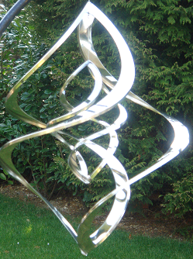 | 4 SS Large Nova (SNNL01)  18”x13”/ 46x33 cm  6 SS Medium Nova (SNNM02)  14”x9.5”/33.5x24cm | £18.75  £16.75 | £42.99  £37.99
 | 4 SS Large Plain Nova (SPNL03)  18”x13”/ 46x33 cm  6 SS Medium Plain Nova (SPNM4)  14”x9.5”/33.5x24cm  6 SS Small Plain Nova (SPNM5)  11”x5.5”/28x14cm | £13.00  £11.25  £6.95 | £29.99  £25.99  £15.99
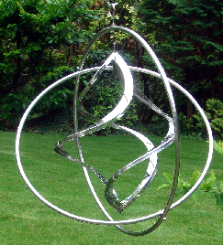 | 4 SS Gyroscope Nova (SNG03)  14”x9.5”/35.5x24cm | £14.50 | £32.99
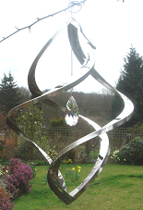 | 6 SS Crystal Nova (SCN07)  13”x8.50”/28x21cm  8 SS Mini Crystal Nova (CPNMC06)  8”x4”/20.5x10cm | £11.25  £6.95 | 25.99  £15.99

Starter Pack Includes:
- 46 Wind Dancers
- 24 SS Hanging Hook (For Wd's) @ £1.30
- FREE loan of Stand (accommodates up to 16 products) & One Pedestal Fan
- FREE delivery

Total cost £ 549.00
Trade prices exclusive of VAT
On offshore orders shipping charges may apply

Home to Garden Ltd .8A Lower Road Chorleywood Herts, <br/>WD3 5LH
<br/>Tel/Fax: 01923 467 372, Mob 07980 893605: Email: home2gardenltd@yahoo.co.uk<p/>

